**Knowledge for Development:**

**Global Partnership Conference 2017**

**Geneva, 3-4 April 2017**

Palais des Nations, Conference Room XXIV

**Conference announcement**

The Global K4D Conference is aimed at the review and advancement of knowledge management practices in the field of sustainable development and presenting a new agenda to strengthen knowledge societies and economies for development. The Conference will provide insights in current practices and explore future developments in the use of knowledge management in the area of development. **Knowledge is at the heart of global development.** It is the critical resource for development organisations to work and collaborate successfully as well as for communities, cities, nations and regions to create wealth, quality of living, peace and sustainability. Knowledge is an essential, overarching element for the achievement of Agenda 2030 and the Sustainable Development Goals, and therefore requires the world´s full attention.

****As a first highlight, the Joint Inspection Unit will launch its 2016 Report of the **“Knowledge Management in the United Nations System.”** The best practices highlighted in report and the ways and means to implement the recommendations made by JIU will be discussed by United Nations representatives and partners from the civil society organizations, private companies, academia and knowledge management professionals.

As a second highlight, the “**Agenda Knowledge for Development”** will be presented including the first set of *Knowledge Development Goals*. This Agenda, initiated by KMA and supported by a global community of thought leaders, brings a new and integrated view on the challenges and opportunities related to knowledge and provides orientation to all stakeholders in the field of development.

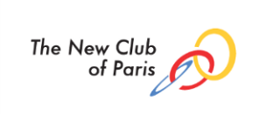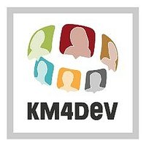The Conference is co-organized by the Joint Inspection Unit of the UN and Knowledge Management Austria, and hosted at and facilitated by the UN Office at Geneva, in cooperation with the following partner organisations:

There is no registration fee for the conference which is open to all, subject to registration.

** Knowledge for Development: Global Partnership Conference 2017**

**Programme outline**

**Day one**

The first day will see the opening of the conference by high-level diplomatic and UN representatives. Session 1 will see the introduction of the two flagship documents:

* Launching of the JIU Report on Knowledge Management in the United Nations system (JIU/REP/2016/10), by Dr. Petru Dumitriu, Inspector, Joint Inspection Unit
* Presentation of the Agenda Knowledge for Development by Dr. Andreas Brandner, KMA Knowledge Management Austria

After the lunch break, Session 2 will present good practices in knowledge management from the UN system, moderated by Steve Glovinsky, including the UN Development Programme (UNDP), the International Atomic Energy Agency (IAEA), the International Labour Organisation (ILO), the International Fund for Agricultural Development (IFAD) and the UN Educational, Scientific and Cultural Organization (UNESCO). Session 3 will then represent an open discussion on measuring the impact of knowledge management, followed by a knowledge market (Session 4) at which participants will share their organisational approaches, achievements, failures and learnings in an informal session.

****The final event on the first day will be the presentation of the two 2017 Knowledge Management Awards by Dr. Andreas Brandner of KMA. The organisational award will be presented to Dr. Petru Dumitriu, recognising the work of the Joint Inspection Unit in raising the profile of knowledge management in the United Nations and further afield. The recipient of the individual award is still to be announced.

**Day two**

The opening session (Session 5) on day two will comprise a multi-stakeholder approach to knowledge for development, featuring presentations by the private sector, universities, non-governmental organisations, diaspora organisations and the media. In Session 6, some best practices will be presented including:

* Arab Knowledge Report by the MBR Foundation and the UNDP
* Capacity4Dev, DG International Cooperation and Development, ECTBC
* Knowledge for Development without Borders
* Climate Knowledge Brokers Group
* DgroupsTBC

This will be followed by a knowledge café on ‘Advancing Knowledge for Development’ (Session 7), facilitated by Peter Bury. The final session represents a fishbowl discussion of the issues raised during the conference (Session 8). This will be followed by the closing ceremony.

Prior to the Conference on Sunday 2 April 2017, there will be a meeting of the Knowledge Management for Development community to which all participants will also be welcome. Follow latest news on see the [KM4Dev wiki](http://wiki.km4dev.org/KM4Dev2017Geneva#Background).

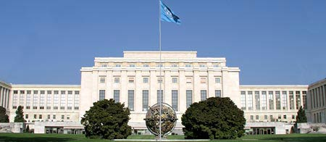

**Venue**

Palais des Nations, Conference Room XXIV

8-14, Avenue de la Paix

Porte Pregny

Geneva

**Conference Chairs**

Dr. Petru Dumitriu, Inspector, JIU

Dr. Andreas Brandner, KMA/KM4Dev/NCP

Dr. Sarah Cummings, Knowledge Ecologist/KMA/KM4Dev

Peter Bury MSc, KM4Dev

Prof. DI Günter Koch, KMA/NCP

Helen Gillman MA, IFAD/KM4Dev

**Organisation and Registration**

Joint Inspection Unit and the UN Office at Geneva

**Websites of partner organisations, with related information and discussions**

[www.km-a.net](http://www.km-a.net)

[www.k4dev.knowledge.city](http://www.k4dev.knowledge.city)

[www.km4dev.org](http://www.km4dev.org)

[www.thenewclubofparis.org](http://www.thenewclubofparis.org)

[www.unjiu.org](http://www.unjiu.org)

[www.knowledgefordevelopmentwithoutborders.org](http://www.knowledgefordevelopmentwithoutborders.org)